Cash Stash

Financial Management Application

Team Members

Cameron Kubik – cmk0037@auburn.edu – Team Leader

Sean Ramuchak – str0005@auburn.edu – Designer

Dylan McCardle – dcm0033@auburn.edu – Programmer

Daniell Yancey – dby0001@auburn.edu – Requirements Engineer

Zachary Hayes – zgh0001@auburn.edu – Architect

Professor Yilmaz

Software Modeling and Design

April 22, 2018

Table of Contents

|  |  |
| --- | --- |
| 1. Domain Analysis |  |
| a. Concept Statement | 3-4 |
| b. Conceptual Domain Model | 5 |
| c. Domain State Model | 6-7 |
| 2. Application Analysis |  |
| a. Application Interaction Model | 8-37 |
| b. Application Class Model | 38-39 |
| c. Application State Model | 40-44 |
| 3. Consolidated Class Model | 45 |
| 4. Model Review | 46-47 |
| 5. Architectural Design | 48-49 |
| 6. Detailed Design |  |
| a. Interaction Design | 50-58 |
| b. Design Class Diagram | 59 |
| c. Class Design | 60-66 |
| 7. Design Quality | 67-68 |

The financial planning application provides financial management utilities for customers via a mobile application interface. Customers should be able connect existing financial tools to the application which generates analysis and graphical interaction. The application will collaborate with Banking, Credit, and Investment institutions that hold accounts of our target customers. Banks and other institutions will process transactions and maintain accounts on their own; the application will access this information through externally. The customer can use the application for personal or institutional purposes with the same result. The application is for customers who have financial assets and liabilities in many places and need a single place to manage them.

The application will enable users to view bank accounts, credit accounts, and investment portfolios in a single point of entry which expedites and organizes the process of evaluating a financial position. Along with creating a single access point for all of a customer’s financial utilities, the application provides functionality to programmatically create a budget based on evaluation of bank and income statements. After analyzing a bank statement required by the Budget component, the application will be able to create a spending tracker and cash flow statement. Customers will be able to set up weekly, monthly and yearly bill reminders. These will be utilized by a Calendar component that reminds customers of upcoming and overdue bills.

The application will be used by individuals and organizations alike. The user interface is provided for mobile phones and tablets as an application downloaded from a phones app store. The app can be used at home, the office, or on the go without sacrificing functionality.

The application provides a solution for the need to consolidate financial assets and liabilities into a single point of access. The ability to create and manage budgets is necessary for those living on a fixed income or anyone looking for a better way to manage their money. The application is intended for day-to-day use and can be utilized at any point in time. Customers’ financial well-being changes every day, this application serves to keep users up to date with those changes.

The application will work by providing a user interface through phones and tablets. The application system will collaborate with Bank, Credit Union, and Investment Firm systems to compile financial information needed for the UX. Each collaborating system (Banks, Credit Unions, and Investment Firms) will hold and maintain individual accounts on the customers behalf but will allow access to the confidential data after login credentials have been supplied.

A user must have an account to use the system. To create an account, the person must enter a valid e- mail address and choose a secure password. Once an account has been created, the user must verify their account by clicking a link in an automated email sent by the system. Once the account has been marked as verified, the user may choose to add additional information to their account such as a phone number, address, date of birth and social security number.

To link external services to an account (this could be a bank, credit card company, billing service), the user must choose a service from the list of supported ones and then provide the username and password associated with the account they wish to link. Once the user submits the data, an external services manager will attempt to verify the information. If the information was able to be verified then the users account data will be synced with their Cash Stash account; otherwise, the user will receive an error message detailing the problem.

Users may also create transactions manually. To create an expense transaction the user would need to specify a name, date and recipient; similarly, to create an income transaction the user would need to specify a name, date and source of the income. The user may also specify if a transaction should be recurring; if so, the user would need to provide the next date that the transaction should take place as well as the frequency on which to perform the transaction. Other attributes such as a category, memo, transaction type and transaction number are optional.

One of the key features of the system allows the user to setup a monthly budget. To create a new budget the user will need to provide an estimate of their gross monthly or annual income. This will generate a suggested budget plan for the user with their monthly income broken down into categories by percentage. The user is free to change these values as well as add or remove categories to customize their budget.

Another thing that the user may like to do is set up savings goals. When a user sets up a savings goal, a certain percentage of their monthly income will be set aside to ensure that they are able to meet their goal. To set this up a user would choose a name for the goal, the amount that they wish to save and the date by which they would need the savings. If a user has a budget setup, then these savings will be deducted from the amount of “free money” set aside for that month. If the user does not have a budget setup, then the user may manually update the value of their savings.

The user can also generate financial reports that provide various ways of summarizing their financial activity. To generate a financial report the user must have entered at least one transaction into the system. Some reports may require additional input from the user such as defining a period for the summary. Like reports, a user can choose to track their credit score through their Cash Stash account. To set up credit tracking, the user must have a complete profile (meaning they have added their address, phone number, social security number, etc.)

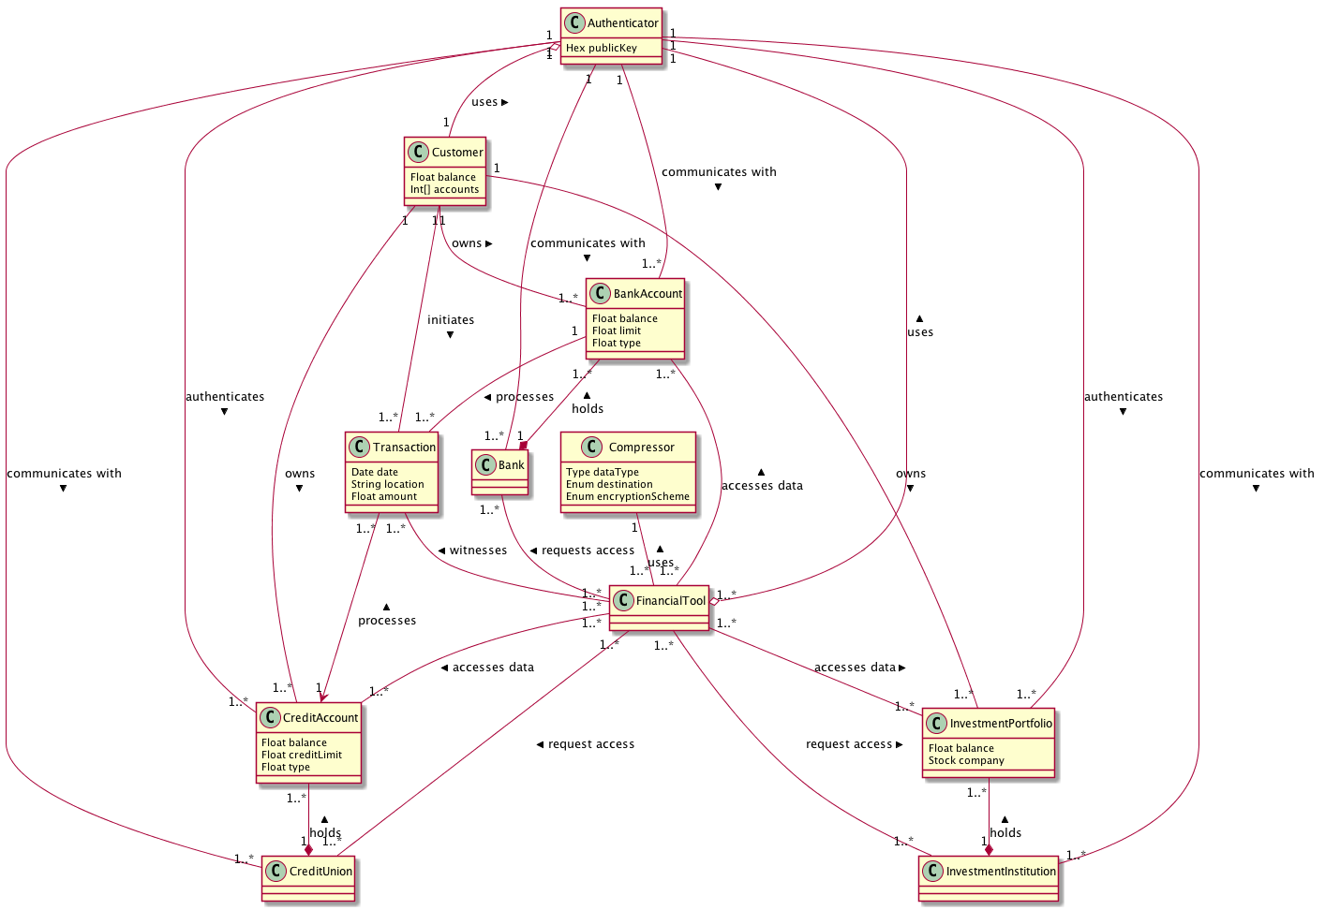

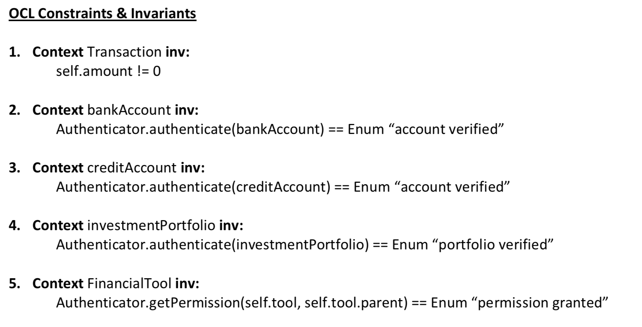

Bank Account State Model

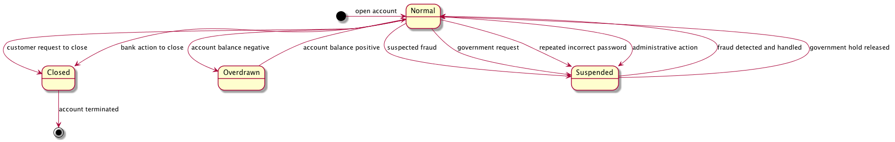

Credit Account State Model

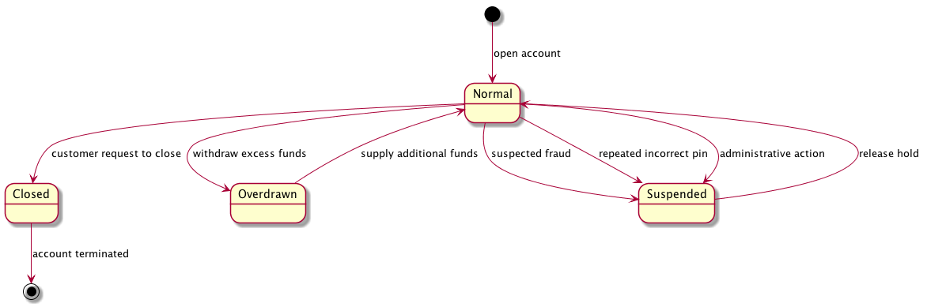

Investment Portfolio State Model

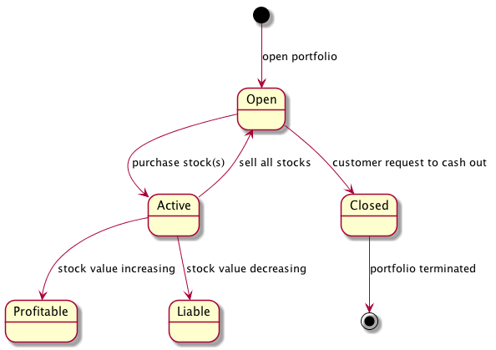

Transaction State Model

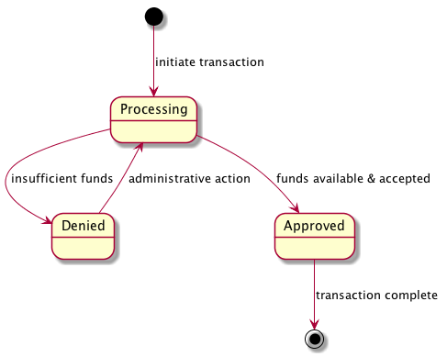

Use Case Diagram

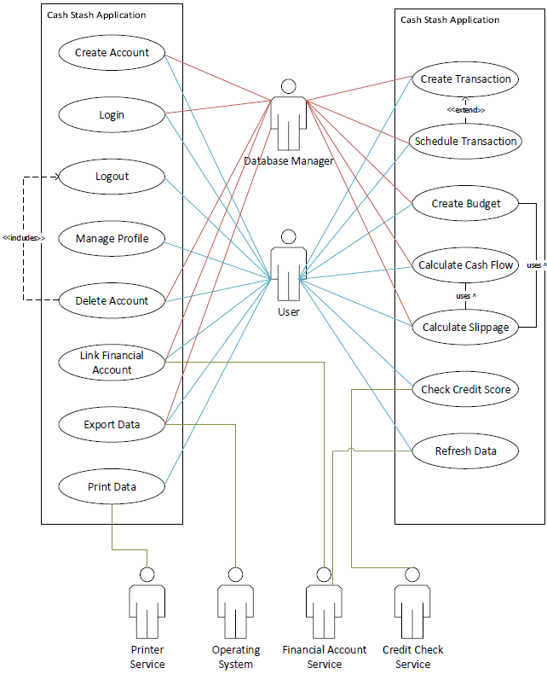

Essential Use Cases

|  |  |
| --- | --- |
| **Create Account**  Pre-condition: The user is on the Cash Stash login screen.  Actors: User (Primary), System (Secondary) | |
| 1. User provides account information. | 1. System validates user information. 2. System creates account. |
| Exceptions:  3a. If the account information couldn’t be validated, then the user will receive an error message.  3b. If the password provided is less than 7 characters, then the user will receive an error message. | |
| Post-condition: The user account is created. | |

|  |  |
| --- | --- |
| **Login**  Pre-condition: The user is on the Cash Stash login screen and has already created an account.  Actors: User (Primary), System (Secondary) | |
| 1. User provides login information. | 1. System validates user information. 2. System logs the user in. |
| Exceptions:  2a. If the account information couldn’t be verified, then the user will receive an error message. | |
| Post-condition: The user is logged in. | |

|  |  |
| --- | --- |
| **Logout**  Pre-condition: The user is logged in to Cash Stash.  Actors: User (Primary), System (Secondary) | |
| 1. User chooses the logout option. | 1. System saves any open data. 2. System logs the user out and displays login screen. |
| Exceptions: | |
| Post-condition: The user is logged out. | |

|  |  |
| --- | --- |
| **Manage Profile**  Pre-condition: The user is logged in to Cash Stash.  Actors: User (Primary), System (Secondary) | |
| 1. User chooses the manage profile option. 2. User submits account settings. | 1. System loads the account settings screen. 2. System saves account information and loads the main screen. |
| Exceptions:  4a. If the account settings are missing information, an error message is displayed. | |
| Post-condition: The user’s account information is updated. | |

|  |  |
| --- | --- |
| **Delete Account**  Pre-condition: The user is on the “Account Settings” screen of the Cash Stash application.  Actors: User (Primary), System (Secondary) | |
| 1. User chooses the delete account option. 2. User submits account password. | 1. System prompts the user for their account password. 2. System erases all data related to the user’s account and displays the login screen. |
| Exceptions:  4a. If the user fails the account verification step, an error message will display. | |
| Post-condition: The user’s account and data no longer exist. | |

|  |  |
| --- | --- |
| **Link Financial Account**  Pre-condition: The user is on the “Account Settings” screen of the Cash Stash application.  Actors: User (Primary), System (Secondary), Financial Account Service (Secondary) | |
| 1. User chooses the link financial account option. 2. User provides financial account details. | 1. System prompts the user for the account details. 2. System sends account details to financial account service for authorization. 3. Financial account service authorizes the account details. 4. System syncs financial account information with Cash Stash account. |
| Exceptions:  4a. If there is information missing from the account details, the system will prompt the user to finish filling in the details.  6a. If the account details were not authorized, then the system will display an error message to the user and ask them to try again. | |
| Post-condition: The user’s Cash Stash account is now synced with their financial account. | |

|  |  |
| --- | --- |
| **Create Transaction**  Pre-condition: The user is logged in to Cash Stash.  Actors: User (Primary), System (Secondary) | |
| 1. User chooses the create transaction option. 2. User submits transaction details. | 1. System displays new transaction screen. 2. System verifies transaction details. 3. System saves the transaction. |
| Exceptions:  5a. If the transaction verification fails, the system will display an error message instead of saving the transaction. | |
| Post-condition: The transaction is saved within the user’s account. | |

|  |  |
| --- | --- |
| **Schedule Transaction**  Pre-condition: The user is logged in to Cash Stash.  Actors: User (Primary), System (Secondary) | |
| 1. User chooses the schedule transaction option. 2. User submits transaction details. | 1. System displays new transaction screen. 2. System verifies transaction details. 3. System saves the recurring transaction. |
| Exceptions:  5a. If the transaction verification fails, the system will display an error message instead of saving the recurring transaction. | |
| Post-condition: The recurring transaction is saved within the user’s account. | |

|  |  |
| --- | --- |
| **Create Budget**  Pre-condition: The user is logged in to Cash Stash.  Actors: User (Primary), System (Secondary) | |
| 1. User chooses the create budget option. 2. User submits budget settings. | 1. System displays the new budget screen. 2. System verifies budget settings. 3. System displays the budget report. |
| Exceptions:  5a. If the budget settings are missing information, the system will display an error message instead of creating the budget.  5b. If the sum of percentages for categories is less than 0 or greater than 100, the system will display an error message. | |
| Post-condition: The budget report is displayed. | |

|  |  |
| --- | --- |
| **Calculate Cash Flow**  Pre-condition: The user is logged in to Cash Stash.  Actors: User (Primary), System (Secondary) | |
| 1. User chooses the calculate cash flow option. 2. User chooses a timeframe for the cash flow. | 1. System prompts the user for a timeframe. 2. System calculates income and expense transactions for given timeframe. 3. System displays cash flow report. |
| Exceptions:  4a. If the account doesn’t contain any transactions within the given timeframe, the system will display an error message. | |
| Post-condition: The cash flow report is displayed. | |

|  |  |
| --- | --- |
| **Calculate Slippage**  Pre-condition: The user is logged in to Cash Stash and has setup a budget.  Actors: User (Primary), System (Secondary) | |
| 1. User chooses the calculate slippage option. 2. User chooses the timeframe for which to calculate slippage. | 1. System prompts the user to choose a timeframe. 2. System loads budget and calculates cash flow. 3. System displays a slippage report which compares values from the budget to the actual cash flow. |
| Exceptions: | |
| Post-condition: The slippage report is displayed. | |

|  |  |
| --- | --- |
| **Check Credit Score**  Pre-condition: The user is logged in to Cash Stash and has completed their account identity information.  Actors: User (Primary), System (Secondary), Credit Check Service (Secondary) | |
| 1. The user chooses the check credit score option. | 1. System will query the credit check service for the user’s credit score. 2. Credit check service verifies the identity information and gets the credit score. 3. System displays the user’s current credit score. |
| Exceptions:  4a. If the credit check service returns an error, the error message is displayed to the user instead. | |
| Post-condition: The user’s credit score is displayed. | |

|  |  |
| --- | --- |
| **Export Data**  Pre-condition: The user is logged in to Cash Stash.  Actors: User (Primary), System (Secondary), Operating System (Secondary) | |
| 1. User chooses the export data option. 2. User chooses a save location. | 1. System prompts the user to choose a location to save the file. 2. System will compile an excel file of the account transactions. 3. System sends a request to the operating system to save the excel file. |
| Exceptions:  4a. If the account doesn’t contain any transactions, an error message will display to the user. | |
| Post-condition: The operating system receives the create file request. | |

|  |  |
| --- | --- |
| **Print Data**  Pre-condition: The user is logged in to Cash Stash.  Actors: User (Primary), System (Secondary), Print Service (Secondary) | |
| 1. User chooses the print data option. | 1. System will send a request to the printer service to print the current screen. |
| Exceptions: | |
| Post-condition: The printer service receives the print request. | |

|  |  |
| --- | --- |
| **Refresh Data**  Pre-condition: The user is logged in to Cash Stash.  Actors: User (Primary), System (Secondary), Financial Account Service (Secondary) | |
| 1. User chooses the refresh data option. | 1. System request a sync operation from the financial account service. 2. Financial account service will respond with the appropriate data. 3. System reloads the current screen. |
| Exceptions:  4a. If any of the sync requests returned with an error, these error messages will be displayed to the user before reloading the current screen. | |
| Post-condition: The user’s Cash Stash account now contains any data in linked financial accounts. | |

Scenarios

|  |
| --- |
| **Create Account** |
| John Doe opens the login screen. John Doe provides login information. Joh Doe chooses the create account option. System verifies account availability. System creates a new account. System establishes a steady connection. System displays main screen. |

|  |
| --- |
| **Login** |
| John Doe opens the login screen. Joh Doe provides login information. John Doe chooses the login option. System verifies login information.  System establishes a steady connection.  System displays main screen. |

|  |
| --- |
| **Logout** |
| John Doe logs in.  John Doe chooses the logout option.  System saves any open data. System terminates steady connection.  System displays login screen. |

|  |
| --- |
| **Manage Profile** |
| John Doe logs in. John Doe chooses the manage profile option. System grabs account settings. System displays manage profile screen. John Doe updates profile settings. John Doe chooses the save option. System validates new account settings. System saves account settings. System displays main screen. |

|  |
| --- |
| **Delete Account** |
| John Doe logs in.  John Doe opens manage profile. John Doe chooses the delete account option. System prompts John Doe for the account password. John Doe enters the account password. John Doe chooses the delete option. System verifies the account password. System erases all account data. System displays the login screen. |

|  |
| --- |
| **Link Financial Account** |
| John Doe logs in. John Doe opens manage profile. John Doe chooses the link financial account option. System prompts the user to provide the login information for the account. John Doe chooses the financial institution and provides the account login information. System sends the login information to the financial account service to request a connection.  Financial account service verifies the account information. System creates a transaction for each record found in the financial account.  System displays a success message. |

|  |
| --- |
| **Create Transaction** |
| John Doe logs in. John Doe chooses the create transaction option.  System displays the new transaction screen. John Doe enters transaction information. John Doe chooses the save option. System verifies the transaction details. System saves the transaction. System displays the transaction log screen. |

|  |
| --- |
| **Schedule Transaction** |
| John Doe logs in. John Doe chooses the schedule transaction option. System displays the schedule transaction screen. John Doe enters the transaction information. Joh Doe chooses the save option. System verified the transaction details. System sets up a recurring transaction. System displays the main screen. |

|  |
| --- |
| **Generate Budget Report** |
| John Doe logs in.  John Doe chooses the create budget option.  System displays the budget settings screen. John Doe creates budget categories and assigns percentage or fixed amount values to each category. John Doe chooses the save option. System verifies the budget settings. System saves the budget.  System displays the main screen. |

|  |
| --- |
| **Calculate Cash Flow** |
| John Doe logs in. John Doe chooses the calculate cash flow option.  System verifies that the account contains transactions. System prompts for a timeframe to display the cash flow for. John Doe enters a timeframe. John Doe chooses the calculate option. System verifies that the timeframe has transactions.  System calculates cash flow.  System displays the cash flow report. |

|  |
| --- |
| **Print Data** |
| Joh Doe logs in.  John Doe chooses the print data option. System sends a request to the printer service to print the cash flow screen. |

|  |
| --- |
| **Refresh Data** |
| John Doe logs in.  John Doe chooses the refresh data option.  System sends a request to each linked financial account to perform a data sync.  System reloads the current screen. |

|  |
| --- |
| **Calculate Slippage** |
| John Doe logs in. John Doe chooses the calculate slippage option. System verifies that the account contains transactions. System prompts for a month and year to display slippage for. John Doe chooses a month and year. Joh Doe chooses the calculate option. System verifies that there are transactions available for the given month and year. System calculates slippage. System displays slippage report. |

|  |
| --- |
| **Check Credit Score** |
| Joh Doe logs in. John Doe chooses the check credit score option. System grabs account information. System queries the credit check service with identity information from account.  Credit check service verifies account information and retrieves a credit score estimate. System displays the credit score. |

|  |
| --- |
| **Export Data** |
| John Doe logs in. Joh Doe chooses the export data option. System prompts the user for a save location. Joh Doe chooses a save location. System will compile an excel document containing all transaction data saved in the account. System sends a request to the operating system to save the excel file.  Operating System saves the excel file. |

High-Level SSD

|  |
| --- |
| **Create Account** |
|  |
|  |

|  |
| --- |
| **Login** |
|  |
|  |

|  |
| --- |
| **Logout** |
|  |
|  |

|  |
| --- |
| **Manage Profile** |
|  |
|  |

|  |
| --- |
| **Delete Account** |
|  |
|  |

|  |
| --- |
| **Link Financial Account** |
|  |
|  |

|  |
| --- |
| **Create Transaction** |
|  |
|  |

|  |
| --- |
| **Schedule Transaction** |
|  |
|  |

|  |
| --- |
| **Create Budget Report** |
|  |
|  |

|  |
| --- |
| **Calculate Cash Flow** |
|  |
|  |

|  |
| --- |
| **Calculate Slippage** |
|  |
|  |

|  |
| --- |
| **Check Credit Score** |
|  |
|  |

|  |
| --- |
| **Export Data** |
|  |
|  |

|  |
| --- |
| **Print Data** |
|  |
|  |

|  |
| --- |
| **Refresh Data** |
|  |
|  |

Concrete Use Cases

|  |
| --- |
| **Create Account** |
| Pre-condition: The user is on the application login screen. |
| Event Flow:   1. The user fills the login form with the email address and password they wish to sign up with and then clicks the “Create Account” button. 2. The system validates the account. Meaning that it checks to make sure the email address provided does not belong to an existing account. 3. The system creates a new account in the database using the provided email address and password and the user is logged in to the application.    1. If an account was found with the matching email address, then an error message displays informing the user that they must use a different email address.    2. If the password entered is less than 7 characters, then an error message displays informing the user that they must choose a stronger password. |
| Post-condition: The user account is created and logged in. |

|  |
| --- |
| **Login** |
| Pre-condition: The user is on the application login screen and has already created an account. |
| Event Flow:   1. The user fills the login with the email address and password corresponding to their account. 2. The system performs account verification by searching the database for an account with the matching email address and password combination.    1. If no such account could be found, then an error message displays informing the user that the provided email address and password do not match an account. 3. The system logs the user in using the account found in account verification. |
| Post-condition: The user account is logged in. |

|  |
| --- |
| **Logout** |
| Pre-condition: The user is logged in to the application. |
| Event Flow:   1. The user clicks the “Logout” button. 2. The system checks the current screen for any unsaved data and attempts to save it, then the system logs the user out and displays the login screen. |
| Post-condition: The user is logged out of the application. |

|  |
| --- |
| **Manage Profile** |
| Pre-condition: The user is logged in to the application. |
| Event Flow:   1. The user clicks the “Manage Profile” button. 2. The system displays the “Account Settings” screen with a form containing account information populated from the database. 3. From this screen, the user can choose to edit their email, password, identity information, link and unlink financial accounts, create alerts and delete their account. When the user finishes making changes, they click the “Save” button. 4. The system saves any changes made to the account in the database and displays the main screen.    1. If the account settings are missing information, then an error message is displayed informing the user of which fields need to be corrected. |
| Post-condition: The user’s account information is updated. |

|  |
| --- |
| **Delete Account** |
| Pre-condition: The user is logged in and has loaded the “Account Settings” screen. |
| Event Flow:   1. The user clicks on the “Delete Account” button. 2. The system displays a prompt for the user to enter their password as a confirmation that they wish to delete all their account data from the application database. 3. The user enters their account password and clicks the “Delete” button. 4. The system erases all the data associated with the user’s account and displays the application login screen.    1. If the supplied password does not match the one for the account, an error message displays informing the user than they entered an incorrect password. |
| Post-condition: The user’s account data no longer exists. |

|  |
| --- |
| **Link Financial Account** |
| Pre-condition: The user is logged in and has loaded the “Account Settings” screen. |
| Event Flow:   1. The user clicks on the “Link Financial Account” button. 2. The system displays a prompt for the user to choose a supported financial institution from a dropdown list and then provide the username and password associated with the account they wish to link. 3. The user chooses a financial institution, enters their username and password and clicks the “Continue” button. 4. Based on the financial institution selected by the user, the system sends a request to the financial account service to access an account that matches the provided username and password.    1. If the user did not select an institution or provide a username and password, then an error message displays asking the user to correct those issues. 5. The financial account service receives the request and looks for an account with a matching username and password. If an account is found, then the service responds with authorization to access the account data. If the account could not be found, the service responds with an error message. 6. The system establishes a connection to the financial account through the financial account service and begin downloading a history of transaction data.    1. If the financial account service returned an error, this error message is displayed back to the user instead of establishing a connection. |
| Post-condition: The financial account is now linked to the user’s Cash Stash account. |

|  |
| --- |
| **Create Transaction** |
| Pre-condition: The user is logged in to the application. |
| Event Flow:   1. The user clicks on the “Create Transaction” button. 2. The system displays the “New Transaction” screen. This screen contains a form with fields for the user to enter transaction information. Required fields include a title, date of transaction, amount and type of exchange (cash, check, credit, etc.). Optional fields include a category, memo and transaction number (check #, etc.). 3. When the user finishes filling out the form, they click the “Save” button. 4. The system verifies that all the required information for creating a transaction has been filled out properly. 5. The system creates a new transaction with the details provided by the user and displays the “Transaction Log” screen.    1. If transaction detail verification fails, then an error message is displayed informing the user of which fields need to be corrected before attempting to save the transaction. |
| Post-condition: The transaction is saved in the user’s account. |

|  |
| --- |
| **Schedule Transaction** |
| Pre-condition: The user is logged in to the application. |
| Event Flow:   1. The user clicks on the “Schedule Transaction” button. 2. The system displays the “New Transaction” screen. This screen contains a form with fields for the user to enter details about the recurring transaction. Required fields include a title, date of transaction, amount, type of exchange (cash, check, credit, etc.), the next date the transaction should occur and the frequency at which to keep performing the transaction. Optional fields include a category, memo and transaction number. 3. When the user is finished entering the transaction details, they click the “Save” button. 4. The system verifies that all the required information for creating a recurring transaction has been filled out properly. 5. The system creates a new recurring transaction with the details provided by the user and displays the “Transaction Log” screen.    1. If transaction detail verification fails, then an error message displays informing the user of which fields need to be corrected before attempting to save the transaction. |
| Post-condition: The recurring transaction is saved within the user’s account. |

|  |
| --- |
| **Create Budget** |
| Pre-condition: The user is logged in to the application. |
| Event Flow:   1. The user clicks the “Create Budget” button. 2. The system displays the “New Budget” screen. On this screen the user is required to provide their gross monthly income and define categories to be used in the budget. For each category the user also needs to provide a percentage or fixed amount of income they wish to set aside for it. 3. The user fills out the required fields in the budget report form. Once the user has finished setting up their budget, they click the “Save” button. 4. The system verifies that the user has filled out all the required fields in the “New Budget” screen. 5. Based on the settings chosen by the user, the system calculates how much of the user’s gross monthly income should be set aside for each category in the budget. The system then displays the budget report.    1. If the verification step finds missing information, an error message displays that informs the user of which fields need to be corrected.    2. If the verification step find that the sum of percentages defined for categories is less than 0 or greater than 100, then an error message displays informing the user to correct the percentage values. |
| Post-condition: A budget report is displayed based on settings chosen by the user. |

|  |
| --- |
| **Calculate Cash Flow** |
| Pre-condition: The user is logged in to the application. |
| Event Flow:   1. The user clicks the “Calculate Cash Flow” button. 2. The system displays a prompt for the user to choose a month and year as a timeframe for generating the report. 3. The user chooses a month and a year from the provided lists and clicks the “Continue” button. 4. The system calculates the total income and expenses for transactions found within the timeframe chosen by the user. These totals are also broken down by category based on the categories defined within each transaction item. If a transaction item does not contain a category, it is assigned to the category “Other”.    1. If no transactions were found within the chosen timeframe, an error message displays informing the user that the system couldn’t find any transactions. 5. The system displays a cash flow report that summarizes the details previously calculated. |
| Post-condition: A cash flow report is displayed based on settings chosen by the user. |

|  |
| --- |
| **Calculate Slippage** |
| Pre-condition: The user is logged in to the application and has setup a budget. |
| Event Flow:   1. The user clicks the “Calculate Slippage” button. 2. The system displays a prompt for the user to choose a month and year as a timeframe for calculating slippage. 3. The user chooses a month and year from the provided lists and clicks the “Continue” button. 4. The system loads the budget associated with the user’s account and calculates the cash flow for the chosen timeframe. 5. The system compares the total values from the budget to the cash flow broken down by category. This shows the user how close they stayed to the goals setup in their budget. These results are displayed as a slippage report. |
| Post-condition: A slippage report is displayed based on settings chosen by the user. |

|  |
| --- |
| **Check Credit Score** |
| Pre-condition: The user is logged in to the application and has completed their account identity information. |
| Event Flow:   1. The user clicks the “Check Credit Score” button. 2. The system loads the user’s identity information from their account and sends this to the credit check service, asking for a credit score estimate in return. 3. The credit check service verifies the identity and performs a credit score lookup. 4. The system displays the user’s credit score as received by the credit check service.    1. If the credit check service couldn’t verify the identity information, it returns an error message. This message is displayed to the user instead of their credit score. |
| Post-condition: The user’s credit score is displayed. |

|  |
| --- |
| **Export Data** |
| Pre-condition: The user is logged in to the application. |
| Event Flow:   1. The user clicks the “Export Data” button. 2. The system displays prompt for the user to choose a location for saving the data file. 3. The user chooses a save location and clicks the “Continue” button. 4. The system compiles an excel file; each row in the file contains information related to a transaction contained within the user’s account.    1. If the system doesn’t find any transactions in the user’s account, an error message displays informing the user that it couldn’t find any transactions. 5. The system sends a request to the operating system to create the excel file at the user’s chosen save location. |
| Post-condition: The operating system receives the create file request. |

|  |
| --- |
| **Print Data** |
| Pre-condition: The user is logged in to the application. |
| Event Flow:   1. The user clicks the “Print Data” button. 2. The system sends a request to the printer service to print the current screen. |
| Post-condition: The printer service receives the print request. |

|  |
| --- |
| **Refresh Data** |
| Pre-condition: The user is logged in to the application. |
| Event Flow:   1. The user clicks the “Refresh Data” button. 2. The system grabs each of the linked financial accounts for the current user. For each financial account the system sends a data sync request to the appropriate financial account service. 3. The financial account service validates the account information provided and respond with transaction data related to that account. 4. After all accounts have synced, the system reloads the current screen.    1. If the financial account service returned error messages for any of the requests, then these error messages are displayed to the user before the screen gets reloaded. |
| Post-condition: The user’s account now contains all transaction data from any linked financial accounts. |

Detailed SSD

|  |
| --- |
| **Create Account** |
|  |
|  |

|  |
| --- |
| **Login** |
|  |
|  |

|  |
| --- |
| **Logout** |
|  |
|  |
|  |
|  |
| **Manage Account** |
|  |
|  |

|  |
| --- |
| **Delete Account** |
|  |
|  |
|  |

|  |
| --- |
| **Check Credit Score** |
|  |
|  |

|  |
| --- |
| **Link Financial Account** |
|  |
|  |

|  |
| --- |
| **Create Transaction** |
|  |
|  |

|  |
| --- |
| **Schedule Transaction** |
|  |
|  |

|  |
| --- |
| **Create Budget** |
|  |
|  |

|  |
| --- |
| **Calculate Cash Flow** |
|  |
|  |

|  |
| --- |
| **Calculate Slippage** |
|  |
|  |
|  |
| **Export Data** |
|  |
|  |

|  |
| --- |
| **Print Data** |
|  |
|  |

|  |
| --- |
| **Refresh Data** |
|  |
|  |

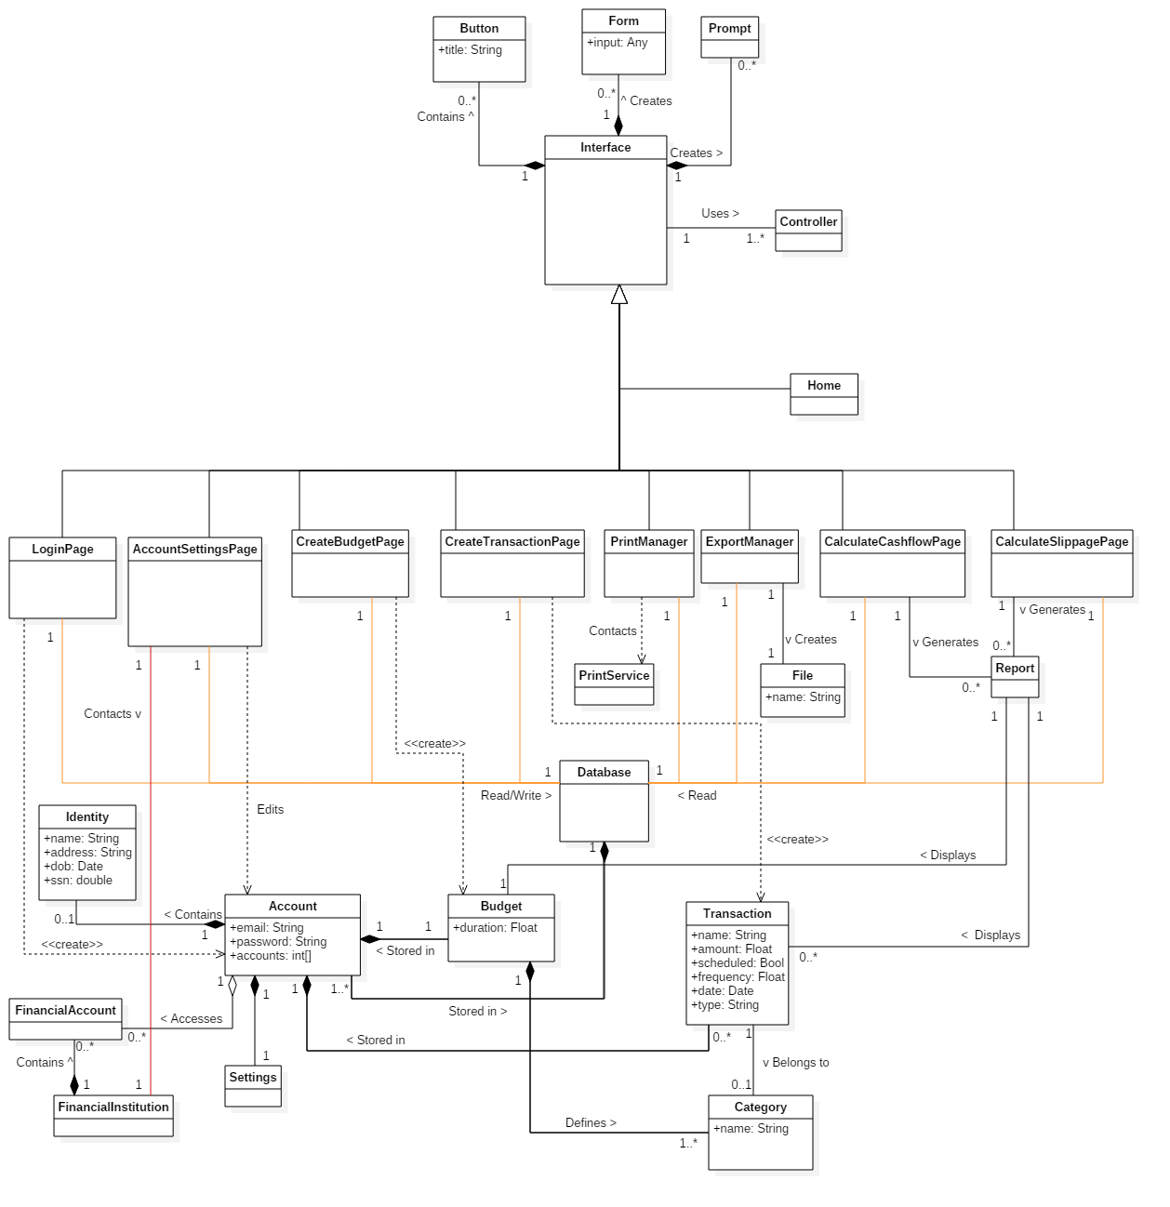

OCL Constraints & Invariants

* Context Transaction inv:

self.amount != 0

* Context FinancialAccount inv:

Authenticator.authenticate(FinancialAccount) == Enum “account verified”

* Context Budget inv:

self.limit > 0

self.type != NULL

* context Login::login()

pre: UserAccount -> forAll(self.loggedIn = false)

post: userAccount.loggedIn = true

|  |
| --- |
| **Create Account** |
|  |
|  |

|  |
| --- |
| **Login** |
|  |
|  |

|  |
| --- |
| **Logout** |
|  |
|  |

|  |
| --- |
| **Manage and Delete Account** |
|  |
|  |

|  |
| --- |
| **Link Financial Account** |
|  |
|  |

|  |
| --- |
| **Create/Schedule Transactions** |
|  |
|  |

|  |
| --- |
| **Create Budget Report** |
|  |
|  |

|  |
| --- |
| **Calculate Cash Flow** |
|  |
|  |

|  |
| --- |
| **Calculate Slippage** |
|  |
|  |

|  |
| --- |
| **Check Credit Score** |
|  |
|  |

|  |
| --- |
| **Export Data** |
|  |
|  |

|  |
| --- |
| **Print Data** |
|  |
|  |

|  |
| --- |
| **Refresh Data** |
|  |
|  |

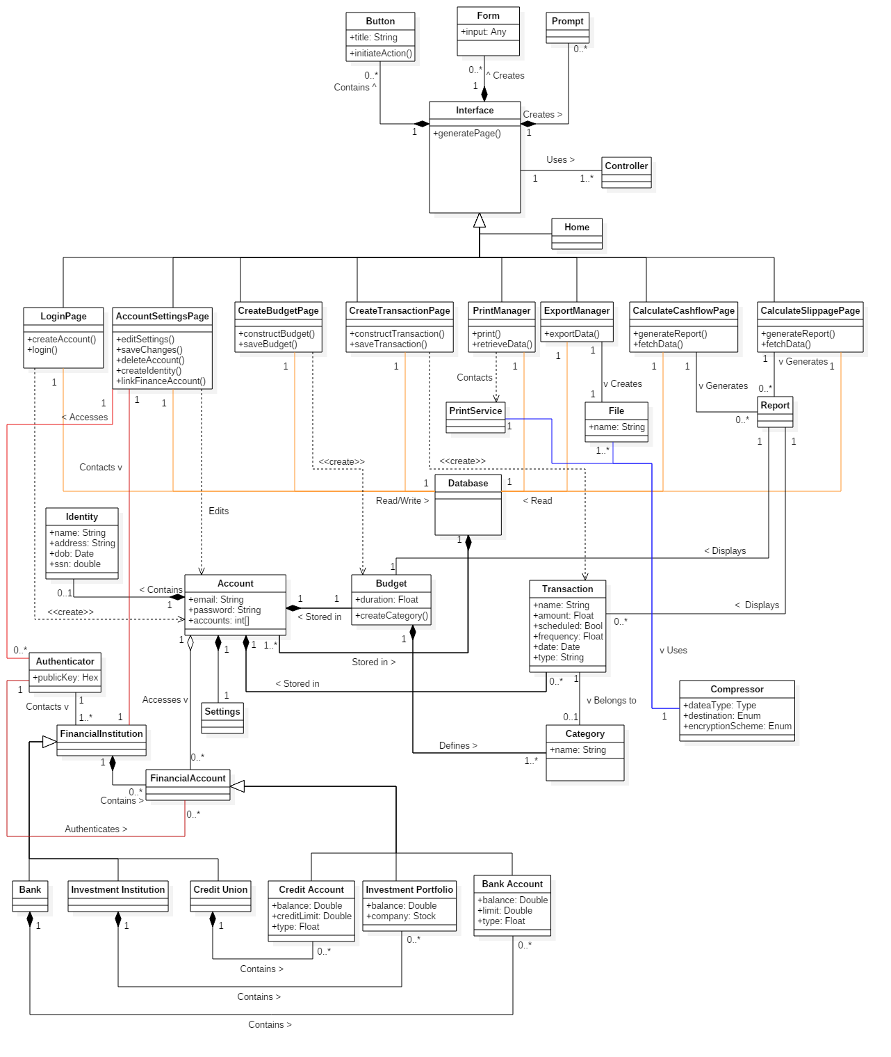

This document outlined the project analysis portion of a personal finance manager called Cash Stash using an Object-Oriented and UML design modeling process.

The Domain Analysis portion attempts to describe the Cash Stash application on a very general level and does not aim to elaborate on how the application functions internally. The Concept Statement is a generally explains the purpose of the application, who can use it, the features it provides and how it interacts with external systems. Using information from the concept statement, a Conceptual Domain Model (CDM) was generated to show the relationships between high-level systems that make up the applications logic. While most of these associations refer to constructs local to the program, some of them may interact with external systems such as a financial institution. Another type of association shows child-parent relationships, meaning one construct (the child) may inherit the ideas and attributes of another (the parent). The Domain State Model (DSM) elaborates the ideas presented in the CDM by showing their various states and behaviors. The associations between states in the DSM shows what initiates a change of state and these ideas where fabricated with the help of information found within the concept statement.

The Application Analysis portion aims to describe the Cash Stash application on more of an application specific level, meaning it shows in detail how each feature will function and how the internal components of the application interact with each other. The Application Interaction Modal (AIM) describes fifteen different use cases of the application. First, an essential use case will describe a step-by-step interaction between the user, the Cash Stash system and any external systems in general terms. These step-by-step interactions also show how to handle exceptions, which are unexpected actions that may occur during the process. Next, a scenario is written that shows the interaction previously described by the essential use case but using a third person point of view; such as, “John Doe enters his username”. After the scenario, a High-level System Sequence Diagram (HSSD) is created that shows the essential use case in graphical form. The graphical form is easier to understand because it shows a clear interaction between the user and the system with arrows pointing in the direction of the interaction and a message that shows the action being performed. Some internal actions are also represented as additional text on the system side of the chart. These three concepts (essential use case, scenario, HSSD) explain the application use cases in a quick and concise form. Now the concrete use cases will expand the concepts in essential use cases to provide more detail about what is happening during these interactions. For example, where an essential use case may say “System validates information”, the concrete use case will say “The system checks to make sure the email address provided does not belong to an existing account”. Furthermore, the concrete use cases are also converted into a graphical form called the Detailed System Sequence Diagram (DSSD). The DSSD has a similar style to the HSSD but it shows more information than just the interactions between the user and the system. The DSSD also contains boundary objects that represent the interface with which the user interacts to initiate a process, control objects which manage the rest of the interaction within a use case and entity objects which are representations of the data being created by a process. For each DSSD, a control object is created due to the interaction between a user and a boundary object, then the control object may or may not request further interaction from the user throughout the process. Similar to the CDM and DSM from the Domain Analysis portion, an Application Class Model (ACM) shows the relationships between the different objects found in the DSSD and an Application State Model (ASM) shows the various states and behaviors of each application use case. While the ACM shows associations of objects among all use cases, the ASM will show the state changes of each use case based on the incoming and outgoing interactions with their respective control objects found in the DSSD.

The Consolidated Class Model aims to combine the CDM with the ACM to show how the individual processes of the application interact with the more general systems. By taking the CDM and comparing it with the ideas in the ACM, some of the concepts were similar enough that they could be consolidated into one construct which helped simplify the system.

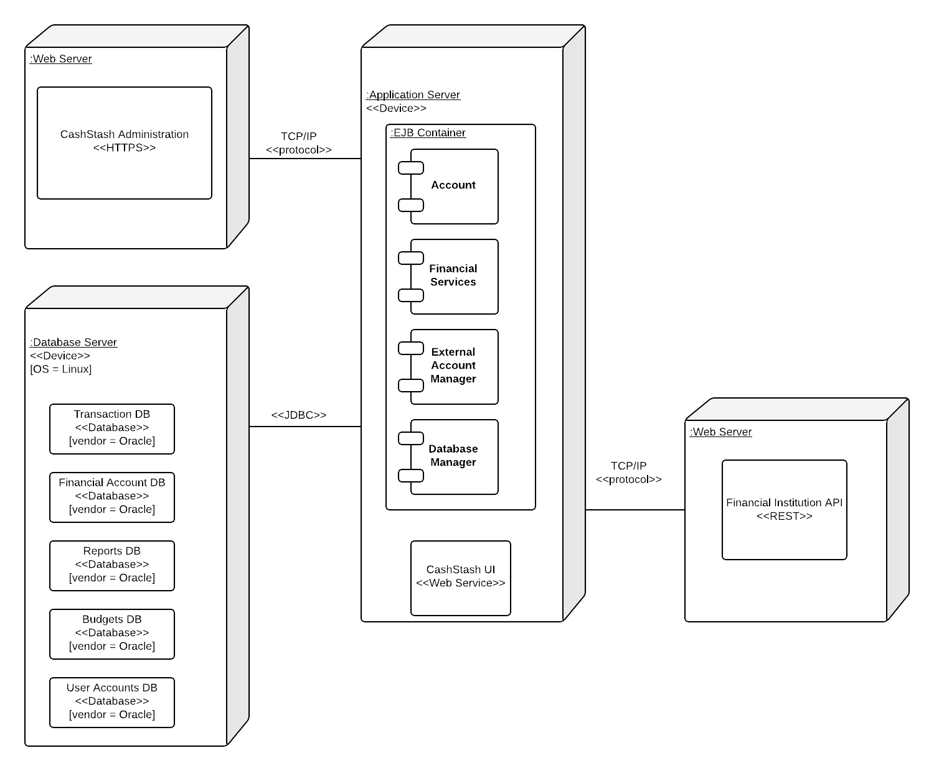

The most appropriate architectural style for our financial management application is the repository model. The rationale for this decision is fairly straightforward. The application will have many sub-systems that are able to compute different figures and statistics based on a user’s financial account transactions. Since all sub-systems will have to draw from the same batch of data, the repository model fits best.

The repository model offers several advantages including an efficient way to share large amounts of data. The sub-systems of this model see data as a black-box, they are not concerned with how it is produced. The repository schema provides a uniform, published model for the sharing of data between sub-systems. However, the repository model carries along with it some disadvantages. The sub-systems must agree on the repository schema, which often leads to compromises. The evolution of repository data is expensive and difficult to maintain. Management policies have no specific scope within the application. The repository can be difficult to distribute efficiently in some cases.

Our deployment diagram employs 3 nodes following a 3-tier architecture, a web-server, an application server, and a database server. All of the use cases described in our analysis phase are allocated to the application server node. Within this node, the use cases can be distributed between the subsystems for Account, Financial Services, and External Account Manager. The Account subsystem handles the use cases for create account, login, logout, manage profile, and delete account. The Financial service subsystem handles the use cases for create transaction, schedule transaction, create budget, calculate cash flow and slippage, export data, and print data. The External account manager handles the use cases for link financial accounts, check credit score, and refresh data

Collaboration Diagrams

|  |
| --- |
| **Create Account** |
|  |
|  |
| This diagram shows the process of the application checking if a username provided when creating an account is available (not already used). This diagram shows the grasp pattern of information expertise because any information being sent and received from the database is handled by a database manager instead of by various objects. Also, the control pattern is present since data control is responsible for delegating the tasks associated with this method. |
|  |
| This diagram represents the process of creating a new account object. The grasp pattern of indirection is represented by the first message so that the Account object never has to directly interact with the application DB. The account control handles talking to the DB manager for the account object and similarly, the DB manager handles interacting with the Account DB for the Account control object; showing the principle of informatino expertise and don’t talk to strangers. |

|  |
| --- |
| **Manage Account** |
|  |
|  |
| The process outlined in this diagram shows a user’s account settings being updated. The account control object represents three grasp patterns alone: information expertise, controller and high cohesion. The account control object is handling the delegation of tasks to other parts of the program and also keeps any manipulation of data within its class since it is pertaining to account information. |

|  |
| --- |
| **Delete Account** |
|  |
| This diagram represents the process of an account being deleted from the database and consequently logging that user out of the system. This diagram shows the control grasp pattern in the sense that account control is delegating each task to the class or system that it relates closest. This leads to the idea of high cohesion as well since each class is solely responsible for performing a certain set of tasks. For example, the session control object takes the responsibility of logging out because the account control object deals with data manipulation, whereas the session control is solely responsible for setting up the current user’s session with the application. |

|  |
| --- |
| **Login** |
|  |
|  |
| This diagram represents the process of finding an account entry from the database and setting it as the current user. The Session Control and the Account Control classes are representing the control grasp pattern since they are responsible for delegating the different steps to the most relevant part of the system. Information expertise is at play here since the Session Control delegates the tasks associated with account objects to the Account Control and similarly with the Account Control delegating database requests to the DB Manager. |

|  |
| --- |
| **Logout** |
|  |
|  |
| This diagram is a simple representation of the process for logging out of the system. This diagram shows the principle of information expertise since the session control maintains responsibility of the overall logout action but passes control over to the Account Control in order to manipulate data associated with the current user. |

|  |
| --- |
| **Create Transaction and Schedule Transaction** |
|  |
|  |
| These two diagrams are the same for both use cases because they both create transaction objects; however, a scheduled transaction extends a normal transaction with extra information. While not exactly present in the diagram… the transaction control is responsible for the creation of the transaction object which then returns itself to the transaction control for further manipulation which represents the creator grasp pattern. Further, the transaction control delegates the process of saving the transaction in the database to the DB Manager which promotes the idea of information expertise and high cohesiveness. |

|  |
| --- |
| **Link Financial Account** |
|  |
|  |
| This diagram shows the process of the application requesting access to an external financial account service. The services control object represents the control grasp guideline since it delegates the tasks needed to complete the operation to the most relevant classes. Also the information expert and high cohesion grasp patterns apply to the DB Manager since it is solely responsible for handling messages being sent to the application’s databases. |
|  |
| This diagram represents the process of getting transaction data from an external financial account service. This diagram represents high cohesion, information expertise and don’t talk to strangers. High cohesion and information expertise can be seen since the services control and the transaction control both send data that isn’t relevant to their specific purpose off to other parts of the system. This concept promotes the idea of don’t talk to strangers since the transaction control handles interactions with the DB Manager instead of the services control. |

|  |
| --- |
| **Check Credit Score** |
|  |
|  |
| This diagram explains the process of getting piece of the current user’s account information (called the identity) from the account database. Information expertise is represented by the fact that services control reaches out to the session control to provide a piece of information that is relevant to the current user. The idea of don’t talk to strangers is also represented when the session control simply returns data to the services control to be sent to the DB Manager instead of directly speaking with the DB Manager. |
|  |
| This diagram is pretty simple because most of the work is handled by an external system. This diagram just shows that our financial application will send a request for a credit score using the identity information saved in the user’s account. Information expertise and high cohesion apply to this diagram in similar ways; the sole purpose of the services control object is to interact with external services and then provide that data to the rest of the system. |

|  |
| --- |
| **Create Budget and Calculate Cash Flow** |
|  |
|  |
| This diagram represents the process of loading transactions from the application’s transactions DB for generating reports. This diagram is lowly coupled since reports control has minimal interaction with the other classes. Information expert and high cohesion were also a factor in the design by delegating the getUser task to the Account Control (which is responsible for manipulating account object data) and assigning any DB queires to the DB Manager. |

|  |
| --- |
| **Calculate Slippage** |
|  |
|  |
|  |
|  |
| The first diagram explains how a user’s budget settings will be loaded from the database and the second shows the process of loading a user’s transactions. The two diagrams for calculating slippage are the same in process but perform different tasks. Both of these diagrams are lowly coupled since the reports control class minimally interacts with two other classes (DB Manager, Account Control). Also, the delegation of tasks being split up among the Account Control and the DB Manager mimics the information expert principle. |

|  |
| --- |
| **Export Data** |
|  |
|  |
| The controller guideline is demonstrated here since the data control is the main object initiating the chain of events. Information expert and high cohesion both apply here since the account control is strictly responsible for the manipulation of account objects and the transaction control being responsible for manipulating transaction objects. Further, the DB manager handles all messages sent/received from an application database. |
|  |
| The grasp guideline of information expertise is clearly demonstrated here with the delegation of tasks being split up to the classes that is most relevant to each one. Similarly, this diagram is highly cohesive in the sense that each object has a specific set of tasks that it is responsible for. The relationship between the data control and file also represent a creator pattern since data control is responsible for the creation of file. |

|  |
| --- |
| **Print Data** |
|  |
|  |
| The data control object represents a couple grasp guidelines here. The first would be the creator guideline since it is responsible for creating a report object with the data it receives from the transaction control. The second guideline could be indirection since it is acting as a middle-man for getting the transaction data needed to generate the report. Information expertise is represented by the report object since generating the table of transactions is a method that is most closesly related to the reports class. |
|  |
| This diagram shows the creator grasp guideline because the data control object is responsible for creating a file object. The data control object also represents the controller grasp guideline since it manages the interactions for that part of the subsystem. |

|  |
| --- |
| **Refresh Data** |
|  |
|  |
| This diagram shows information expertise by delegating database interactions to the database manager. The controller guideline is also represented where the services control calls out to the session control to provide a piece of information to continue the current task. |
|  |
| This diagram follows the principles of high cohesion because the services control hands off the work of altering transaction data to another control object that is more specialized in that area. The controller guideline is also present here as the two control objects split interactions for different parts of the application. |

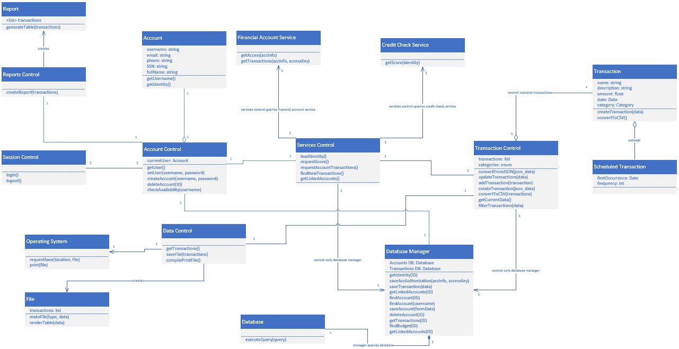

The design class diagram relies heavily on the singleton design pattern. This pattern was chosen with the control objects in mind. Each control object will be responsible for most of operations being performed throughout the system and will interact with object instances as needed. This represents the singleton design pattern well because the control classes will only have one instance that is instantiated at the start of the application and destroyed at the end of the program.

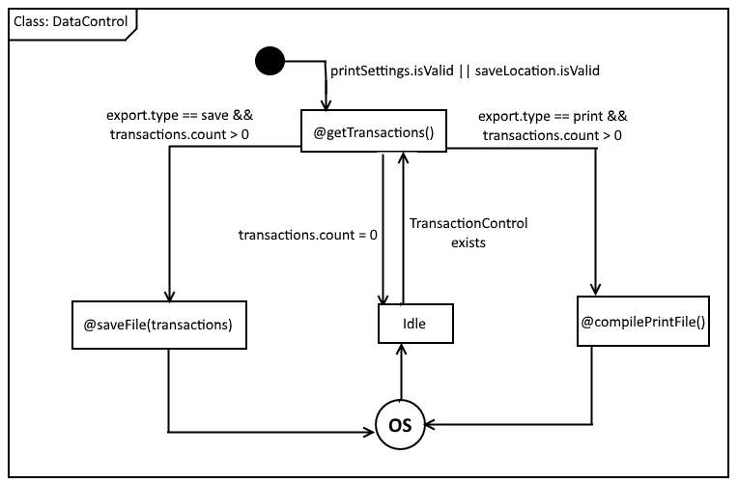

OCL statements:

context DataControl inv: AccountControl.currentUser != null

context DataControl::getTransactions() pre: self.saveLocation->isValid || self.printSettings->isValid

context DataControl::getTransactions() post: File.transactions->count >= 0

context DataControl::saveFile(transactions) pre: File.transactions->count > 0

context DataControl::saveFile(transactions) post: OS.files->includes(File)

context DataControl::compilePrintFile() pre: File.transactions->count > 0

context DataControl::compilePrintFile() post: OS.printQueue->includes(File)

Control flow pseudocode:

getTransactions() {

if (saveLocation.isValid or printSettings.isValid)

pass control to TransactionControl to retrieve transactions

else

error msg/request correct settings

}

saveFile(transactions) {

if (transactions.count > 0)

OS.requestSave(location, file)

else

alert "no transactions to write"

}

compilePrintFile() {

if (transactions.count > 0)

send file to print service

else

alert "no transactions to print"

}

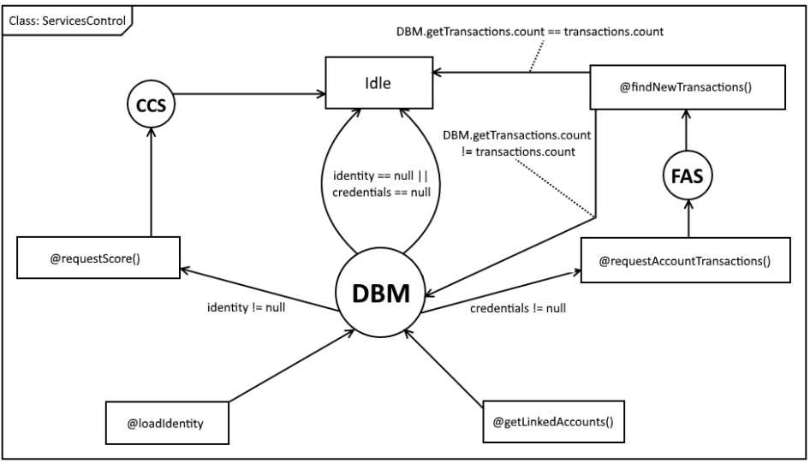

OCL statements:

context ServicesControl inv: AccountControl.currentUser != null

context ServicesControl::loadIdentity() post: self.Identity() != null

context ServicesControl::requestScore() pre: self.Identity() != null

context ServicesControl::requestScore() post: self.Score() != null

context ServicesControl::requestAccountTransactions() pre: self.Credentials() != null

context ServicesControl::requestAccountTransactions() post: self.transactions->count >= 0

context ServicesControl::findNewTransactions() pre: self.transactions->count > 0

context ServicesControl::findNewTransactions() post: DatabaseManager.getTransactions(currentUser)->count == self.transactions->count

Control flow pseudocode:

loadIdentity() {

DatabaseManager.getIdentity(currentUser)

if (identity == null)

error "Identity could not be retrieved"

}

requestScore(identity) {

if (identity != null)

CreditCheckService.getScore(identity)

}

getLinkedAccounts() {

DatabaseManager.getLinkedAccounts(currentUser)

}

requestAccountTransactions() {

if (credentials == null)

FinancialAccountService.getTransactions(credentials)

}

findNewTransactions() {

if (transactions.count > 0) {

for each transaction {

if (transaction not in DatabaseManager.getTransactions())

DatabaseManager.saveTransaction(transaction)

}

}

}

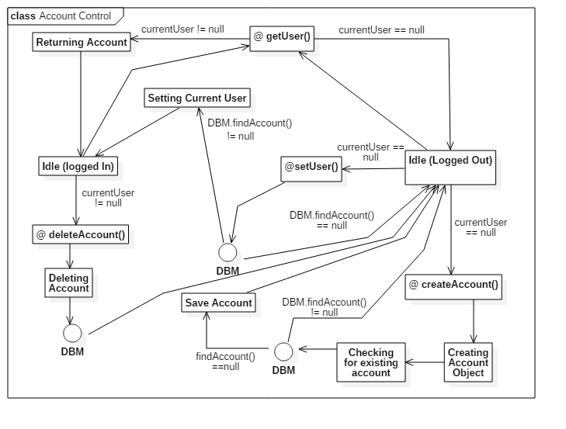

OCL statements:

context AccountControl inv: ServicesControl->exists

context AccountControl inv: DatabaseManager->exists

context AccountControl::setUser(username, password) pre: currentUser == null

context AccountControl::setUser(username, password) post: currentUser.getUserName() == username && currentUser.getPassword() == password

context AccountControl::deleteAccount(username, password) pre: currentUser != null

context AccountControl::deleteAccount(username, password) post: currentUser == null && DatabaseManager.findAccount(username, password) == null

context AccountControl::createAccount(username, password) pre: currentUser == null

context AccountControl::createAccount(username, password) post: DatabaseManager.findAccount(username, password) == newAccount

Control flow pseudocode:

getUser() {

return currentUser;

}

setUser(username, password) {

if (DatabaseManager.findAccount(username, password) == null){

print error;

return;

}

else{

currentUser = DatabaseManager.findAccount(username, password);

}

}

deleteAccount(username, password) {

if (DatabaseManager.findAccount(username, password) == null){

print error;

return;

}

else if (currentUser == DatabaseManager.findAccount(username, password)) {

DatabaseManager.deleteAccount(username,password);

SessionControl.logout();

DatabaseManager.deleteAccount(username,password);

}

else if (currentUser != DatabaseManager.findAccount(username, password)) {

print error;

}

}

createAccount(username, password){

new Account newAccount = Account(username, password);

if (new == DatabaseManager.findAccount(username, password)) {

print error;

return;

}

else {

DatabaseManager.addAccount(newAccount);

SessionManager.login(username,password);

}

}

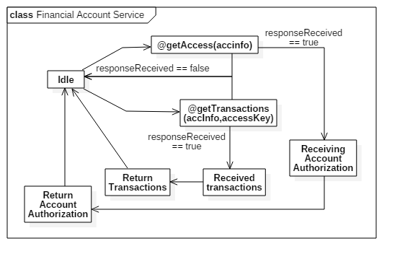

OCL statements:

context FinancialAccountService inv: AccountControl.currentUser != null

Control flow pseudocode:

getAccess(accinfo){

boolean responseRecieved = ping FinancialAccount;

if (responseRecieved == false){

print error;

return;

}

else {

if (send accinfo == wrong_info){

error;

}

request accessKey;

recieve accessKey;

return accessKey;

}

}

getTransactions(accinfo, accessKey) {

boolean responseRecieved = ping FinancialAccount;

if (responseRecieved == false){

print error;

return;

}

else {

if (send accinfo == wrong_info){

error;

}

if (send access key == denied){

error;

}

request json_data;

recieve json_data;

return json_data;

}

}

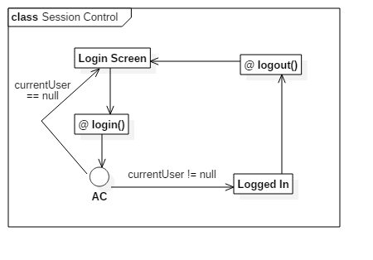

OCL statements:

context SessionControl inv: AccountControl->exists

context SessionControl::login() pre: AccountControl.CurrentUser == null

context SessionControl::login() post: AccountControl.CurrentUser !=null

context SessionControl::logout() pre: AccountControl.CurrentUser != null

context SessionControl::logout() post: AccountControl.CurrentUser == null

Control flow pseudocode:

login(){

prompt user ("input username and password");

AccountControl.setUser(username,password);

if (CurrentUser!=null){

new HomeScreen;

}

else {error;}

}

logout(){

AccountControl.CurrentUser = null;

new LoginScreen;

}